

**User Manual**

**Contents**

* The Story
* System Requirements
* Getting Started
  + Downloading & running the game
  + Controls
* How to play
  + Enemies
  + Items
  + Obstacles
* Contact us

**The Story**

You are on a mission to be the most overpowered duck ever by collecting power ups that are for some reason only found in the mythical land known as the University of York. Also you can get some cool looking sunglasses.

**System Requirements (minimum)**

* **Operating System:**  Windows 7 onwards/Linux
* **Disk Space:**
* **RAM:**

**Getting started**

**Downloading and running the game:**

1. Download the executable game file from: <http://teal-duck.github.io/teal-duck/>
2. Run “BDOC.jar”

**Controls**

WASD - Movement

UP, DOWN , LEFT, RIGHT - Shooting direction

SPACE - Fly

E - Drop bomb

P - Pause

ENTER - Select

ESC/BACKSPACE - Escape/back

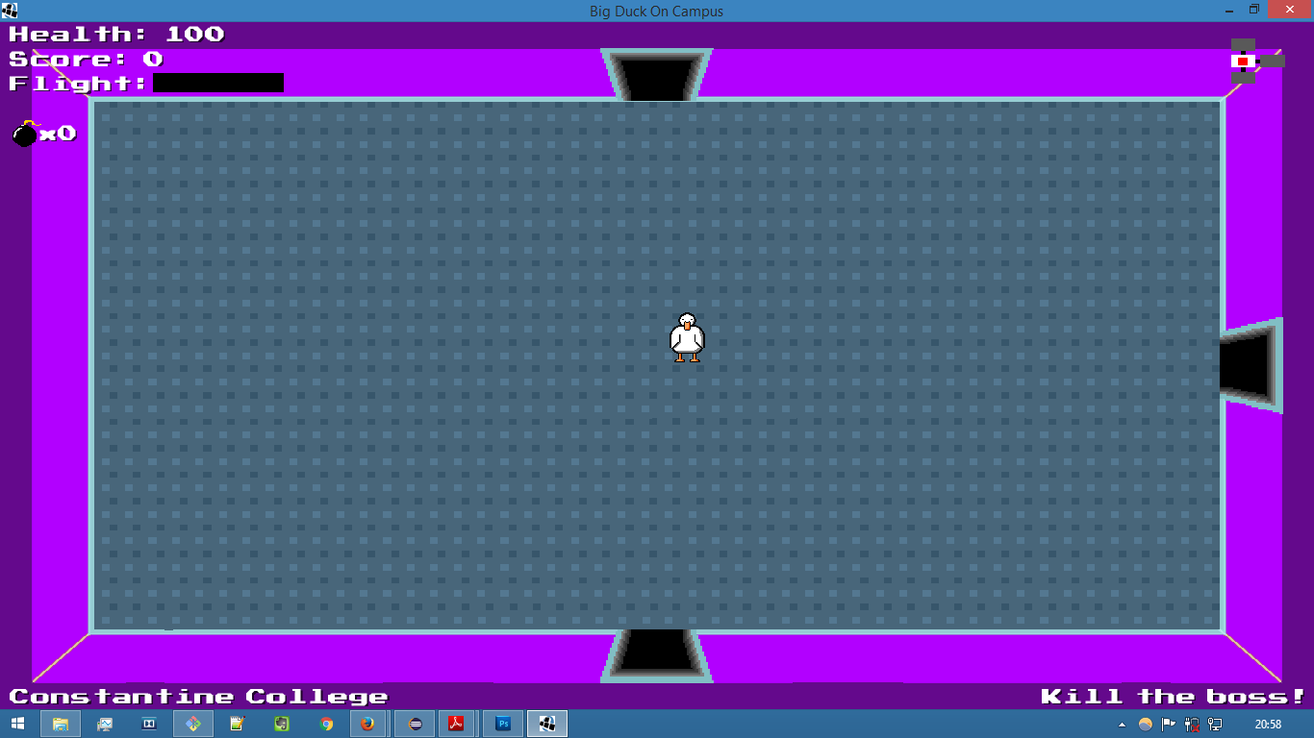

**How to play**

Complete the objectives displayed on the bottom left of the screen in each of the eight levels.

Each time an objective is completed you will gain a new ability that is dropped in the room the objective is completed in.

When you have completed the level objective press P and select another level.

**Game Screen**

* In the top left you will see your Health and Score.
* The Flight bar displays how long you can use your Flight ability (after first receiving the ability from completing an objective).
* The bomb icon on the right shows how many bombs you have in your inventory.
* Top left is the minimap. Standard rooms not visited are grey, if you visit the room it will turn white. The red square indicates which room you are currently in. There are special rooms in the game which are in a different colour.
* Bottom left shows location.
* Bottom right is the level objective.

**Contact us**

Visit our website at:<http://teal-duck.github.io/teal-duck/>

For any further enquiries, email us at: tealduckteam@gmail.com